**CSCI 490 Research Query Results**

**Ethnicity**

1. What is the overall distribution of ethnicities in Los Angeles County schools?
2. What is the distribution of ethnicities among schools that offer Computer Science (CS)?
3. What is the distribution of ethnicities enrolled in CS?

SELECT ethnicities.ethnicity, SUM(`cs_enrollment`) `cs_enrollment`

FROM ethnicities

INNER JOIN cs_enrollments ON cs_enrollments.ethnicity_id=ethnicities.ethnicity_id

GROUP BY ethnicities.ethnicity;

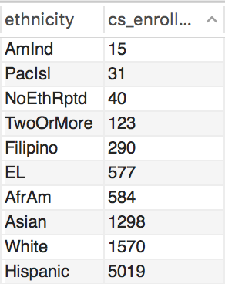

Query Result : CS enrollment by ethnicity for 2014-2015

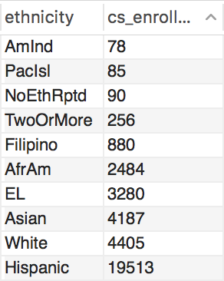

Query Result : CS enrollment by ethnicity from 2012-2015

**Income**

1. What is the overall distribution of income in Los Angeles County schools?
2. What is the distribution of income among schools that offer Computer Science?

MySQL Query : What is the distribution of income among schools that offer Computer Science?

SELECT

CASE

WHEN FRPM_eligible_percent > 0.8 THEN '80-100% FRPM-eligible'

WHEN FRPM_eligible_percent BETWEEN 0.6 AND 0.8 THEN '60-80% FRPM-eligible'

WHEN FRPM_eligible_percent BETWEEN 0.4 AND 0.6 THEN '40-60% FRPM-eligible'

WHEN FRPM_eligible_percent BETWEEN 0.2 AND 0.4 THEN '20-40% FRPM-eligible'

ELSE '0-20% FRPM-eligible'

END AS 'income_brackets',

COUNT(*) AS num_schools

FROM school_info

GROUP BY income_brackets;

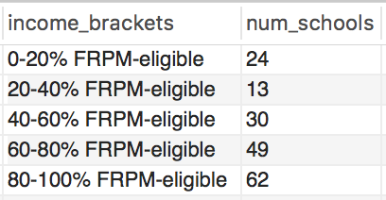

Query Result : FRPM distribution for all CS-offering schools

3. What percentage of the students taking CS attend a low-income school? "High-income" school?*

**Gender**

1. What is the gender distribution of Los Angeles County?
2. What is the gender distribution among schools that offer Computer Science (CS)?
3. What is the gender distribution of students enrolled in CS?

SELECT

CASE

WHEN gender_id = '1' THEN 'Male'

ELSE 'Female'

END AS 'gender',

SUM(cs_enrollment) AS num_students

FROM cs_enrollments

GROUP BY gender;

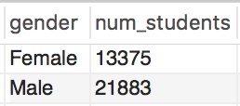

Query Result : Overall gender distribution from 2012-2015

4. How does this compare to the gender distribution of the school?

5. What is the gender distribution at every income tier in Los Angeles County?

6. What is the gender distribution of the ethnicities enrolled in CS?  Female Asians may be more encouraged to participate in STEM courses than female Hispanics.

SELECT ethnicities.ethnicity, SUM(`cs_enrollment`) AS `Males Enrolled`

FROM ethnicities

INNER JOIN cs_enrollments ON cs_enrollments.ethnicity_id=ethnicities.ethnicity_id

WHERE gender_id = 1

GROUP BY ethnicities.ethnicity;

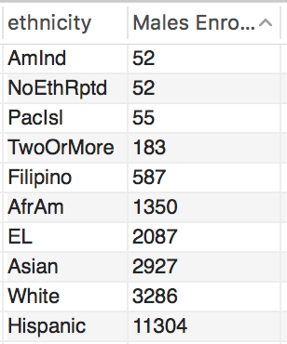

Query Result : Males enrolled in CS from 2012 - 2015

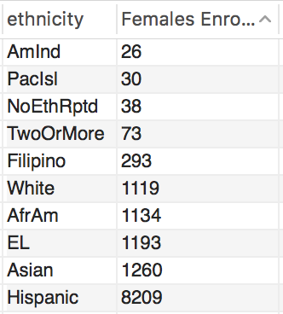

Query Result : Females Enrolled in CS from 2012-2015